First Experiment is briefly explains as below,
Displacement sequence:
- Injecting brine solution.
- Absolute permeability was measured before injecting gas and oil.
First Experiment
Dynamic Viscosity | µ | 0.83 | mPa.s
(solution 15wt% KI) | µ | 0.83 | mPa.s
Length | L | 60.72 | mm
Diameter | D | 12.70 | mm
Permeability | K | 1.02 | D

- Injecting water, oil and gas simultaneously.
- During 4 steps (2-5) the fractions were keeping constant and flowrate was increased.

Flooding Step | Fraction |  |  | Flowrate, ml/min
Flooding Step | Gas | Oil | Water | Gas | Oil | Water
1 | 0 | 0 | 1 | 0 | 0 | 0.1
2 | 0.5 | 0.25 | 0.25 | 0.05 | 0.025 | 0.025
3 | 0.5 | 0.25 | 0.25 | 0.1 | 0.05 | 0.05
4 | 0.5 | 0.25 | 0.25 | 0.2 | 0.1 | 0.1
5 | 0.5 | 0.25 | 0.25 | 0.4 | 0.2 | 0.2

Doubling the flow rate has led to an increase in pressure drop from 30 kPa to 60kPa (30 kPa is very high), as shown in Figure 1a. At the total flowrate 0.4 ml/min we can see a stable pressure drop (20kPa) during first 8 hours, and increasing the flowrate to 0.8 ml/min makes a sharp increasing in pressure drop, which clearly can be indicated by comparing Figure 1c and 1d. The reason for a three-fold increase in pressure drop from 20kPa to 60 kPa at total flowrate 0.4 ml/min still is unknown.
70

60

50

40

30

20

50

40

30

20

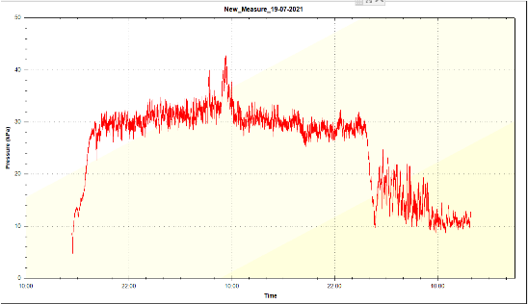
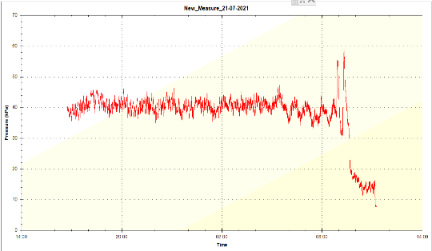
Qg = 0.05
Qw= 0.025
Qo = 0.025
Qg = 0.01
Qw= 0.05
Qo = 0.05
a
b

10

10

80

120
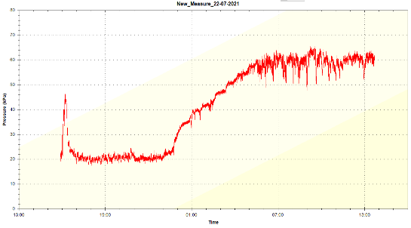
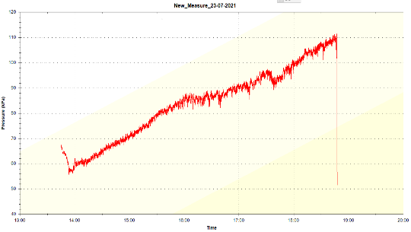
70

60

50

40

30

20

100

90

80

70

60

50

Qg = 0.2
Qw= 0.1
Qo = 0.1
Qg = 0.4
Qw= 0.2
Qo = 0.2
c
d
110

10

40

Figure 1. Pressure drop at different total flowrate during injecting gas, oil and water simultaneously.

